Create Deployment.YAML file,
yaml
Copy code

# Employee Deployment and Service
apiVersion: apps/v1
kind: Deployment
metadata:
name: employee-deployment
labels:
app: ems-employee
spec:
replicas: 3 # Number of replicas for the employee service
selector:
matchLabels:
app: ems-employee
template:
metadata:
labels:
app: ems-employee
spec:
containers:
- name: employee-container
image: yatheesh836/ems:e-i # Docker image for the employee service
ports:
- containerPort: 8191 # Expose port 8191 for employee service

---
apiVersion: v1
kind: Service
metadata:
name: employee-service
spec:
selector:
app: ems-employee # Match the app label from the deployment
ports:
- protocol: TCP
port: 8081 # Port exposed by the service
targetPort: 8191 # Port the container listens on
type: LoadBalancer # Expose externally using LoadBalancer (can use NodePort or ClusterIP as needed)

# Identity Deployment and Service
---
apiVersion: apps/v1
kind: Deployment
metadata:
name: identity-deployment
labels:
app: ems-identity
spec:
replicas: 3 # Number of replicas for the identity service
selector:
matchLabels:
app: ems-identity
template:
metadata:
labels:
app: ems-identity
spec:
containers:
- name: identity-container
image: yatheesh836/ems:identity-i # Docker image for the identity service
ports:
- containerPort: 8191 # Expose port 8191 for identity service

---
apiVersion: v1
kind: Service
metadata:
name: identity-service
spec:
selector:
app: ems-identity
ports:
- protocol: TCP
port: 8082 # Port exposed by the service
targetPort: 8191 # Port the container listens on
type: LoadBalancer # Expose externally using LoadBalancer

# UI Deployment and Service
---
apiVersion: apps/v1
kind: Deployment
metadata:
name: ui-deployment
labels:
app: ems-ui
spec:
replicas: 3 # Number of replicas for the UI service
selector:
matchLabels:
app: ems-ui
template:
metadata:
labels:
app: ems-ui
spec:
containers:
- name: ui-container
image: yatheesh836/ems:ui-i # Docker image for the UI service
ports:
- containerPort: 3000 # Expose port 3000 for UI service

---
apiVersion: v1
kind: Service
metadata:
name: ui-service
spec:
selector:
app: ems-ui
ports:
- protocol: TCP
port: 80 # Port exposed by the service
targetPort: 3000 # Port the container listens on
type: LoadBalancer # Expose externally using LoadBalancer

Employee Service Deployment Explanation:
Deployment Resource:
apiVersion: apps/v1: This is the API version for Kubernetes Deployments.
kind: Deployment: Specifies the resource type (Deployment).
Metadata:
name: employee-deployment: The name of the deployment.
labels: Labels are used to categorize and select resources.
Spec:
replicas: 3: The number of replicas (pods) for the employee service.
selector: Matches the label app: ems-employee, helping Kubernetes identify which pods the deployment will manage.
Template: Defines the pod specification.
Metadata: Labels applied to each pod created by the deployment.
Spec: Defines the containers that will run inside the pod.
containers: Defines a list of containers in the pod.
name: Name of the container.
image: The Docker image to use.
ports: Defines the container's exposed ports (in this case, port 8191).
Service Resource:
apiVersion: v1: The API version for services.
kind: Service: Specifies the resource type (Service).
Spec:
selector: Matches the app: ems-employee label to route traffic to the correct pod.
Ports: Specifies how traffic will be forwarded from the service:
port: 8081: The service port exposed outside the cluster.
targetPort: 8191: The port inside the container where the employee service is running.
type: LoadBalancer: Exposes the service externally using a load balancer.

Checking Deployment, Pods, and Services
After applying the deployment.yaml file, you can check if the pods and services are running correctly using the following commands:
- Check Deployments:
kubectl get deployments
- Check Pods:
kubectl get pods
- Check Services:
kubectl get services
These commands will provide information about the status of your deployments, pods, and services.

Check Running Docker Containers (Local Docker Environment)
If you want to check which Docker containers are running locally,
use: docker container ls
This command lists all the containers that are currently running.

UI Output
You mentioned the output like UI- output 30188, which could be referring to the port or IP address exposed by the UI service. After running the Kubernetes service with a LoadBalancer, you should be able to access the UI application through an external IP or DNS name, often on port 80 (or whatever port the service exposes).
If you need to access the UI service through the external LoadBalancer, check the external IP like this:
kubectl get services
Look for the external IP associated with ui-service under the EXTERNAL-IP column. You can access the UI app via http://<EXTERNAL-IP>:80.
==============#====================#====================#=======

this document ion is me ;
Deployment.yaml file ;
we need to create deployment.yaml file,
vim Doployment.yaml
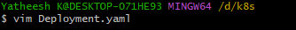
Script ;
This script wraite to the deployment.yaml file,
# Employee Deployment and Service
apiVersion: apps/v1
kind: Deployment
metadata:
name: employee-deployment
labels:
app: ems-employee
spec:
replicas: 3 # Number of replicas for the employee service
selector:
matchLabels:
app: ems-employee
template:
metadata:
labels:
app: ems-employee
spec:
containers:
- name: employee-container
image: yatheesh836/ems:e-i # Docker image for the employee service
ports:
- containerPort: 8191 # Expose port 8191 for employee service

---
apiVersion: v1
kind: Service
metadata:
name: employee-service
spec:
selector:
app: ems-employee # Match the app label from the deployment
ports:
- protocol: TCP
port: 8081 # Port exposed by the service
targetPort: 8191 # Port the container listens on
type: LoadBalancer # Expose externally using LoadBalancer (can use NodePort or ClusterIP as needed)

# Identity Deployment and Service
---
apiVersion: apps/v1
kind: Deployment
metadata:
name: identity-deployment
labels:
app: ems-identity
spec:
replicas: 3 # Number of replicas for the identity service
selector:
matchLabels:
app: ems-identity
template:
metadata:
labels:
app: ems-identity
spec:
containers:
- name: identity-container
image: yatheesh836/ems:identity-i # Docker image for the identity service
ports:
- containerPort: 8191 # Expose port 8191 for identity service

---
apiVersion: v1
kind: Service
metadata:
name: identity-service
spec:
selector:
app: ems-identity
ports:
- protocol: TCP
port: 8082 # Port exposed by the service
targetPort: 8191 # Port the container listens on
type: LoadBalancer # Expose externally using LoadBalancer

# UI Deployment and Service
---
apiVersion: apps/v1
kind: Deployment
metadata:
name: ui-deployment
labels:
app: ems-ui
spec:
replicas: 3 # Number of replicas for the UI service
selector:
matchLabels:
app: ems-ui
template:
metadata:
labels:
app: ems-ui
spec:
containers:
- name: ui-container
image: yatheesh836/ems:ui-i # Docker image for the UI service
ports:
- containerPort: 3000 # Expose port 3000 for UI service

---
apiVersion: v1
kind: Service
metadata:
name: ui-service
spec:
selector:
app: ems-ui
ports:
- protocol: TCP
port: 80 # Port exposed by the service
targetPort: 3000 # Port the container listens on
type: LoadBalancer # Expose externally using LoadBalancer

copy to the this script then paste,
# Employee Deployment and Service
apiVersion: apps/v1
kind: Deployment
metadata:
name: employee-deployment
labels:
app: ems-employee
spec:
replicas: 3 # Number of replicas for the employee service
selector:
matchLabels:
app: ems-employee
template:
metadata:
labels:
app: ems-employee
spec:
containers:
- name: employee-container
image: yatheesh836/ems:e-i # Docker image for the employee service
ports:
- containerPort: 8191 # Expose port 8191 for employee service

---
apiVersion: v1
kind: Service
metadata:
name: employee-service
spec:
selector:
app: ems-employee # Match the app label from the deployment
ports:
- protocol: TCP
port: 8081 # Port exposed by the service
targetPort: 8191 # Port the container listens on
type: LoadBalancer # Expose externally using LoadBalancer (can use NodePort or ClusterIP as needed)

# Identity Deployment and Service
---
apiVersion: apps/v1
kind: Deployment
metadata:
name: identity-deployment
labels:
app: ems-identity
spec:
replicas: 3 # Number of replicas for the identity service
selector:
matchLabels:
app: ems-identity
template:
metadata:
labels:
app: ems-identity
spec:
containers:
- name: identity-container
image: yatheesh836/ems:identity-i # Docker image for the identity service
ports:
- containerPort: 8191 # Expose port 8191 for identity service

---
apiVersion: v1
kind: Service
metadata:
name: identity-service
spec:
selector:
app: ems-identity
ports:
- protocol: TCP
port: 8082 # Port exposed by the service
targetPort: 8191 # Port the container listens on
type: LoadBalancer # Expose externally using LoadBalancer

# UI Deployment and Service
---
apiVersion: apps/v1
kind: Deployment
metadata:
name: ui-deployment
labels:
app: ems-ui
spec:
replicas: 3 # Number of replicas for the UI service
selector:
matchLabels:
app: ems-ui
template:
metadata:
labels:
app: ems-ui
spec:
containers:
- name: ui-container
image: yatheesh836/ems:ui-i # Docker image for the UI service
ports:
- containerPort: 3000 # Expose port 3000 for UI service

---
apiVersion: v1
kind: Service
metadata:
name: ui-service
spec:
selector:
app: ems-ui
ports:
- protocol: TCP
port: 80 # Port exposed by the service
targetPort: 3000 # Port the container listens on
type: LoadBalancer # Expose externally using LoadBalancer

Employee Service

Deployment script expiation;

apiVersion: apps/v1 indicates that this is a Deployment resource.
kind: Deployment defines the resource type.
metadata:
name: employee-deployment is the name of the deployment.
labels: This is a set of labels for identifying and selecting this deployment, e.g., app: ems-employee.
spec:
replicas: 3: This means Kubernetes will maintain 3 replicas of the employee-container running at all times.
selector: This matches the app: ems-employee label, which helps the deployment controller know which pods to manage.
template:
This section describes the pod's template that will be used by the deployment to create new pods. Inside the template:
metadata:
The label app: ems-employee is applied to each pod.
spec:
It describes the container running inside the pod.
containers:
.name: The name of the container within the pod is employee-container.
. image: The Docker image yatheesh836/ems:e-i is used.

Ports ;
This container exposes port 8191, which will be used by the service to route traffic to the correct port in the container.

Chek pods running or not,
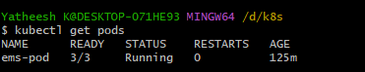

Check container how many containers up,
Docker container ls
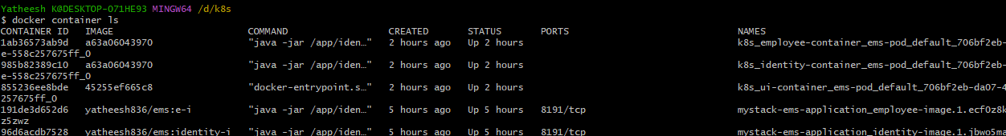
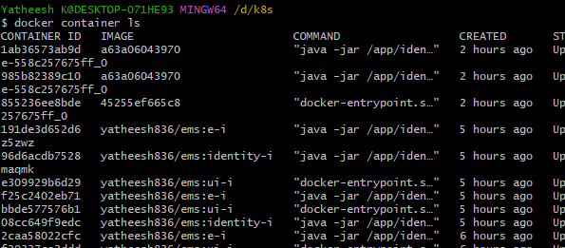

Acces the deployment.yaml file,

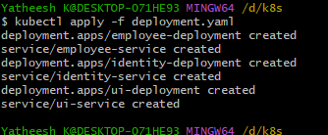

Heare check our deployment,pods and services,
Kubectl get deployment
Kubectl get pods
Kube get service
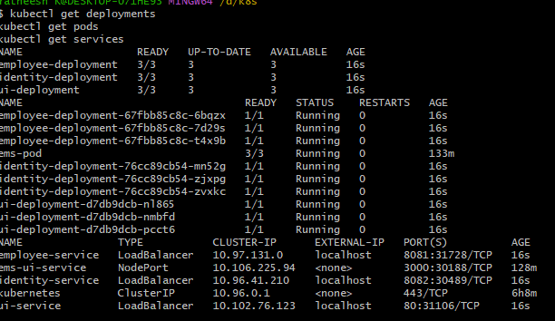

Check kubectl services,
Kubectl get services

Heare check services,
Kubetl get service
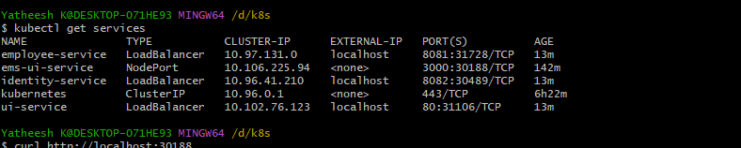

Shows like this application was running,

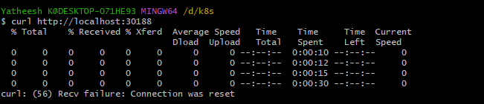

Ui- output 30188

